**FUNDA HELPING PROGRAM**

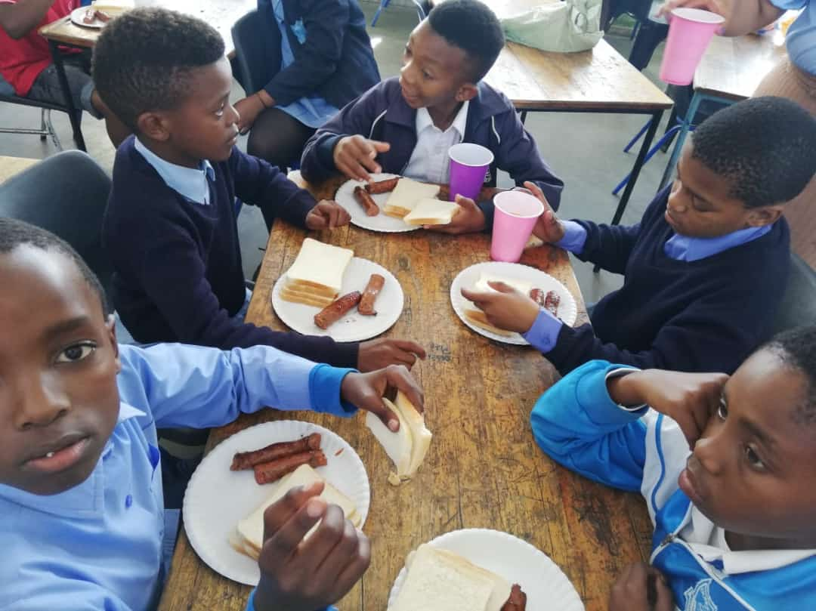

**OVERVIEW REPORT**

**CONTENTS:**

* DEVELOPERS
* BUSINESS OVERVIEW

* OUR GOAL & MISSION

* PROUCTS/SERVICES RENDERED

* PROJECT DESCRIPTION

* MARKETING AND ONLINE MARKETING SKILLS

* HARDWARE REQUIREMENTS
* SOFTWARE REQUIREMENTS
  + FOR FRONT END USERS
  + BACKEND DEVELOPER REQUIREMENTS

* PROJECT TIMELINE

**DEVELOPERS:**

* Gcobani Dike – Web Development(Full stack developer)
* Nontlahla Ntsethe – Data Science(Backend)
* Taahir Hendricks - Data Science(Python expert)
* Yonela Pangalele - Data Science(Business Analysis)
* Nasief Khan – Tester

**BUSINESS OVERVIEW:**

BUSINESS SLOGAN: Go back where you do good

BUSINESS NAME: Funda Helping Program

INDUSTRY: Education & Training

**OUR GOAL & MISSION:**

We are to help South African government in creating more employment youth, by looking on day to day statistics it prove that more unemployment individuals are the one who are uneducated, hence we as Funda Helping Program we are taking this opportunity of helping the primary, senior level and tertiary level students in breaking the chain of poverty in our country. We make them employable by providing them with skills needed by most companies, facilitates them with the important of self-development and continuously learning make education a better way to escape hunger, reduce crime and unemployment rate. Our major services are as following but not limited:

**PRODUCTS/SERVICES RENDERED:**

* Etiquette for success
* Principle for professional success course
* Sale and performance management course
* Skills development solution management performance course
* Skills development solution provider course
* Lifelong learning skills course
* Office orientation workshop
* Microsoft office word 2010 and 2007 course
* Microsoft Excel 2010 and 2007 course
* Outlook , Pastel, SAP, and Oracle
* Microsoft Visio and PowerPoint
* Sales Analysis and Data capturing and analysis course
* Virtual Banking and Regulatory exam 1, and 5
* FICA & FIAS requirements Training course
* Social Visualization skills

**PROJECT DESCRIPTION:**

We are developing a website for our NGO that is based in Phillip. They are providing the following services for South African youth, it also helpful to those who did managed to go to school to have better understanding on our modern world activities and company requirements.

* Etiquette for success
* Principle for professional success course
* Sale and performance management course
* Skills development solution management performance course
* Skills development solution provider course
* Lifelong learning skills course
* Office orientation workshop
* Microsoft office word 2010 and 2007 course
* Microsoft Excel 2010 and 2007 course
* Outlook , Pastel, SAP, and Oracle
* Microsoft Visio and PowerPoint
* Sales Analysis and Data capturing and analysis course
* Virtual Banking and Regulatory exam 1, and 5
* FICA & FIAS requirements Training course
* Social Visualization skills

**MARKETING AND ONLINE MARKETING SKILLS:**

* Content Marketing – To create designs and attract students, educate and maintain our target audiences which are youth of South Africa. We will also use this marketing to attract parents.
* Pay per click – This strategy involves online ads. In this case the moment the user clicks on our advertisement online, a small payment is made to us which we use the money for fundraising or upgrading our business or website.
* Social media marketing – The promoting of our service on social media platforms.
* Email marketing – A marketing approach that uses email as a way of marketing to and advise potential and existing clients.

**HARDWARE REQUIEMENTS:**

* 1 GHz or faster 32-bit (x86) or 64-bit (x64) processor.
* Screen resolution of 1024x768 or higher is recommended.
* 2 GB of RAM is recommended for complex requests and while using tools, such as InfoAssist.
* 3.5 GB free hard disk space for CD installation. 3.5 GB for downloaded installation.

**SOFTWARE REQUIREMENTS:**

***FOR FRONT END USER:***

* HTML/CSS
* JAVASCRIPT/JQUERY
* CSS AND JAVSCRIPT FRAMEWORKS
* CSS PREPROCESSING
* VERSION CONTROL/GIT
* RESPONSIVE DESIGN
* TESTING/DEBUGGING
* BROWSER DEVELOPER TOOLS
* BUILDING AND AUTOMATION TOOLS/WEB PERFORMANCE
* COMMAND LINE

***BACKEND DEVELOPER REQUIREMENTS:***

* Computer science or related field
* More eduction or experience required
* Fluency or understanding of specific languages
* Strong understanding of the web development cycle and programming techniques and tools
* Excellent project and time management skills
* Strong problem solving and verbal and written communication skills
* Ability to work independently or with a group
* Willingness to sit at desk for extended periods

**PROJECT TIMELINE:**

|  |  |  |  |
| --- | --- | --- | --- |
| **ACTIVITY** | **WEEK** | **NAME & SURNAME** | **STATUS** |
| Website creation | 08/10/2020 | Gcobane & Nontlahla | Completed |
| Create content | 13/10/2020 | Yonela & Taahir | Completed |
| Menu Navigation | 20/10/2020 | Gcobani | Completed |
| Page view | 23/10/2020 | Nontlahla | Completed |
| Color scheme | 26/10/2020 | All team | Completed |
| Test site | 23/11/2020 | Nasief | Process |
| Make site live | 26/11/2020 | All team | Process |
| Build or acquire front end(User interface)  Raping up phase and closure. | 03/11/2020 | Nontlahla | Process |